Article

A low-cost and open source Pirani-style vacuum gauge sensor and readout

Alex Smith1,*, Andrew Rice1, and Erik Sánchez1

1 Physics Department, Portland State University, physics@pdx.edu

**\*** Correspondence: alsmit2@pdx.edu

Received: date; Accepted: date; Published: date

**Abstract:** Methods described here use off-the-shelf electronics, provide a software-based calibration cycle, and curve-fits for a custom-made constant temperature Pirani-style pressure sensor. PCB construction and prototyping for a tungsten and glass bead Pirani Gauge is achieved on a single board. Matrix based linear least squares is used to obtain guess parameters that are passed into Matlab’s *fminsearch* function to solve the Non-Linear curve that describes the sensor. Validation of the gauge and associated software were tested against a commercial convection enhanced Pirani style gauge (Convectron®) and capacitive diaphragm gauge (CDG). Tungsten performed better compared to the glass bead thermistor in respect to sensitivity, range, and offset during the calibration cycles. Datalogging of gauge pressure and ambient temperature were evaluated for 24-h periods and illustrate the utility and range of this instrument. This identified the upper limit of gauge measurements to be 2 mbar, and showed a temperature sensitivity 75 mV °C-1. close to ambient pressure.

**Keywords:** Vacuum, Pirani Gauge, Matlab, Arduino, Pressure Sensor, Digital Readout, Glass Bead Thermistor, Tungsten

1. Introduction

Vacuum technology is a key enabler of various technologies and product manufacturing, and is still of great interest in the sciences [1]. Thus, there is still a great need for sensors that detect levels of vacuum quickly, accurately, and in a cost-effective way. Pirani gauges are widely used for vacuum measurement since they were invented by Marcello Pirani in 1906 [2], as they perform quite well in all three categories. Many developments have occurred since, and much of the modern developments have followed the work done by van Herwaarden, when they first described the floating membrane style Pirani which implemented micromachining techniques [3]. Pirani-style sensor research has since focused on fabricating micro-Pirani sensors [4-7]. The advent of low-cost microcontrollers has increased research abilities now exploring low-cost monitored systems [7-9]. Although excellent in the thermal response, a major drawback of this direction is the need for specific equipment that can fabricate floating membrane sensors.

The methods described here make use of predominantly low-cost, off-the-shelf electronics to create a Pirani-style sensor. Analog to digital conversion is done with a Texas Instruments ADS1115 [10] 4-channel ADC and interpreted by an Arduino microcontroller. The system employs a software-based calibration cycle, and generates curve-fits for sensors to circumvent signal conditioning for a custom-made constant temperature Pirani gauge that accurately measures 10-2 to 1 mbar. The software application applies a non-linear least squares (NLLS) solver for a sigmoid function designed for use with a constant temperature Pirani gauge. This is achieved without add-on packages in Matlab® (2018b). The data acquisition system has been made as generalized as possible to promote integration with other sensors. A TMP36 [11] is attached to the 4th channel on the ADS1115 to monitor ambient temperature.

2. Materials and Methods: Pressure Sensor

A Pirani gauge is a type of thermocouple that indirectly senses pressure by measuring heat dissipation of a filament in a vessel. This makes it an indirect measurement gauge where the pressure measurement is inferred from a power measurement. The governing equation for a thermocouple gauge is a conservation of energy at thermal equilibrium. The electrical input balances with thermal dissipation. Energy is lost through solid-to-solid contact, radiation, and interactions with the surrounding gases [12]. Electrical losses will also occur due to advection, but for the purpose of a vacuum gauge is ignored, but can be of specific interest; such as triggering a shutoff valve. Thus, the governing equation regardless of the style of element heating is given by:

|  |  |
| --- | --- |
|  | (1) |

where *Pjoule* is the electrical heating provided by the control circuitry, is the rate of heat loss in the physical gauge, is the rate of heat loss by the residual gas in the gauge and is the rate of heat loss due to radiation of the thermal element.

Two types of Pirani gauges exist that have slightly different calibration curves: constant electrical input and constant temperature. This work uses constant temperature style. Radiation and solid conduction are then essentially constant; however, temperature stability and drift vary with ambient temperature. Thermal transport through the gas is separated in the terms described in the free molecular flow (fmf) regime, which is pressure dependent, and in the viscous flow (vf) regime, which is temperature dependent. Matching the two regimes is given as an inverse sum [13,14]. This is the origin of the sigmoid relationship between heat transports in a Pirani:

|  |  |
| --- | --- |
|  | (2) |

where is the rate of heat loss during the free molecular flow and is the rate of heat loss during viscous flow. Holding the sensing element to a constant temperature drastically reduces the complexity of Equation 1 and 2, where the solid conduction, radiation, and convection terms become constant. This also leads to the resistance of the sensing element to be constant, which allows for power to be measured directly from the square of voltage or current through the filament. By applying these conditions and combining equations 1 & 2, giving the following calibration equation:

|  |  |
| --- | --- |
|  | (3) |

where *V* is the electrical potential, and *P* is the pressure. In this work, pressure is reported in mbar, and the electrical potential is the digitized measurement directly reported from an analog to digital conversion. Though actual heat dissipation depends upon many physical parameters (e.g. material, gas species, gauge geometry, etc.) it is reasonable to assert these are effectively constant throughout the operation of the gauge. Thus *α*, *β*, and *γ* can be treated as simply calibration constants. The most typical reason for an unpredictable change to these parameters is due to darkening of the filament from contamination, which can drastically change the emissivity in radiative heat losses [15]. The more predictable change occurs when measuring different gas species. Glockler & Horst give tables for changes in sensitivity [16] and these values appear in modern vacuum handbooks [17].

Configuring a constant temperature sensing element only requires a self-balancing resistor bridge [18]. If the sensor is too cold, the amplifier applies more power until the resistance has sufficiently increased. If the sensor is too hot, it reduces heating. Glass bead thermistors have been reported [19,20], but have seen little commercial use. To explore using both a tungsten (T5-12V-4V, eTopLighting) and glass bead thermistor (GP101B0M, Littlefuse Inc.) without a different designed printed circuit board (PCB), one was designed to allow proper feedback for the respective positive and negative temperature coefficients of tungsten and glass bead thermistors (See **Figure 1**). The resistors R8, 9, 15 and 16 are shorted or opened to select positive or negative feedback. This selection depends on the sign of the sensing element’s temperature coefficient.

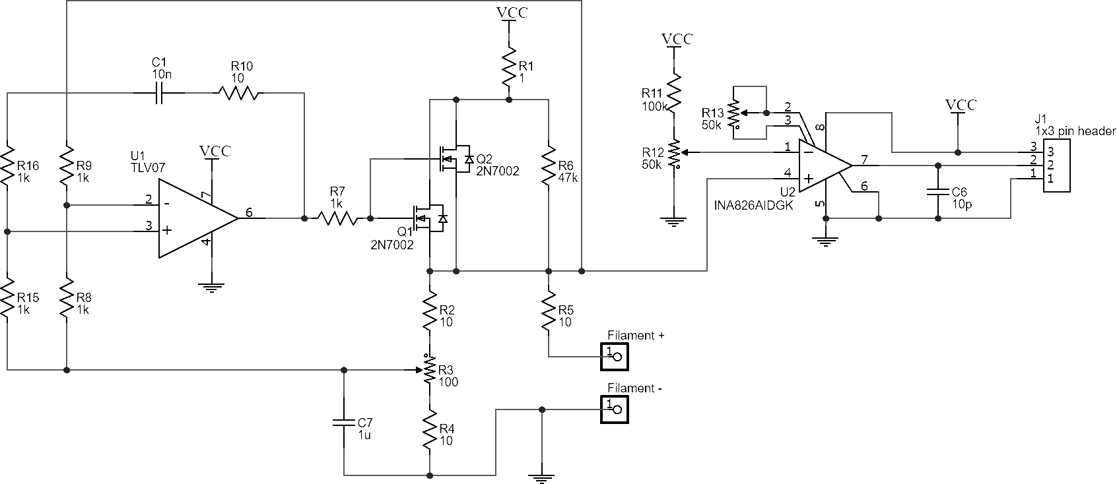

**Figure 1**. A circuit diagram of the Pirani gauge in constant temperature operation. R8, 9, 15, 16 are shorted or opened to select positive or negative feedback depending on the sign of the sensing element’s temperature coefficient.

Advantages from constant temperature operation greatly simplify the governing equation and reduce issues surrounding response time hysteresis caused by thermal relaxation and excitation times [12]. However, this comes at the cost of electrical stability. Various configurations were tested by measuring the output with an oscilloscope. Many configurations were prone to oscillations (~1 kHz). The data acquisition system was too sensitive to the instability as the behavior was inconsistent in amplitude, frequency, and wave-shape from the different configurations. Each sensing element and associated electronics are tuned to eliminate oscillations. Instability is primarily alleviated by selecting R3 to be of a similar resistance to the sensing element, tuning the sensor to a moderate temperature (~100 °C) and selecting a small R10 with a large capacitance, C1. Capacitors C6 and C7 were explored and deemed unnecessary.

The resistors R8, 9, 15 and 16 were added as a way to select the feedback on a PCB depending on the type of sensing element. The tungsten-based filament having a positive temperature coefficient had R9 & 15 shorted with R8 & 16 opened. The glass bead sensors having a negative coefficient had these connections reversed. In both cases a 100 Ω resistor, R3, yielded stable measurements.

Op amps selected were to balance price and performance. The TLV07 [21] gave very reliable results with no noticeable offset issues. The rail-to-rail operation is needed in conjunction with resistor R6 that functions as a start-up for the system at turn-on. Once the device is powered, it will immediately begin balancing the bridge. Measurement conditioning and buffering is done with an INA826 [22]. This instrumentation amplifier is useful for adjusting the output signal to be similar to commercial gauges. With the temperature set, once the gauge is pumped down to vacuum, the output is nulled with the offset adjustment of resistor R12. The system is brought back to atmosphere and the output is scaled to yield ~5 V with resistor R13. Thus, the device can yield 0 – 5 V in the range of vacuum to atmosphere.

An additional board is added to the detector board to interface the data-logging system (**Figure 2**). This board merely contains an RJ12 connector, a 5 V regulator, and an LED for indicating the board is powered. This proved to be convenient as it can be used for any sensor that needs a 5 V supply, with an analog output. TMP36 temperature sensors are attached directly to the power supply boards that were later used to monitor ambient temperature and its effect on gauge performance.

(c)

(b)

(a)

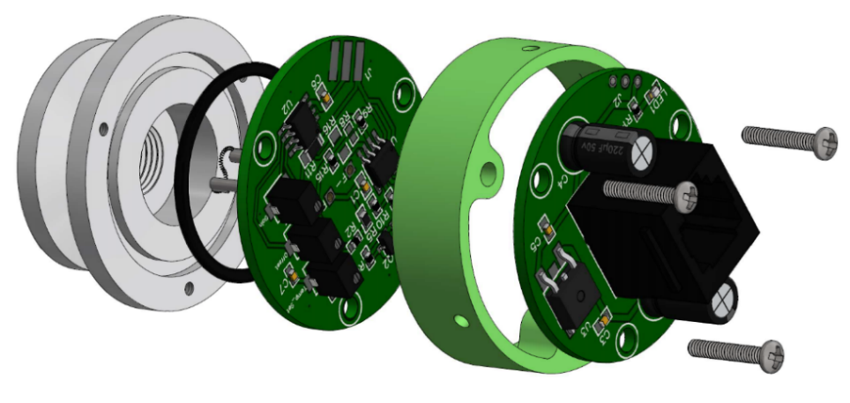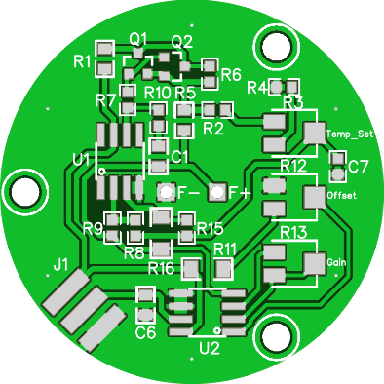

**Figure 2**. Rendered image of the gauge design. (a) PCB for control circuitry and signal conditioning. (b) Pirani gauge developed with a custom aluminum Kwik-Flange (KF) 25 that is o-ring sealed against a PCB. The gauge board is attached to a (c) power supply board that has an RJ12 connector for attaching to the digital readout and data-logger (Left) unpopulated control/conditioning board. (Cover not shown)

The construction of the gauge explores the question of whether a PCB (FR4 material with solder vias) can be used successfully as a vacuum interface. The electronics were designed to use only one side of the PCB, and have two vias for attaching the sensing element. This design for electrical feedthroughs is simple to fabricate, and is adequate for some systems that only need to achieve rough vacuum. For those that require higher quality vacuum interfacing, improvements are discussed in the literature. Superior vacuum performance is achieved by metal coating a glass substrate [23,24].

Attaching the sensing element is straightforward with a glass bead thermistor, as it simply needs to be soldered as close to the PCB as possible. A tungsten filament requires substantially more effort and care. Kovar wires (0.04” diameter x 0.25” length) proved to be a desirable material as can be soldered to the board, and later have the tungsten filament spot welded. Using a tungsten filament extracted from a light bulb, it was necessary to keep the original filament post so there is a larger interface to more easily spot weld to the kovar wire. Difficulty in attaching the tungsten filament lead to designing a relatively large volume for the filament to accommodate any variability in placement of the filament (see **Figure 2(b)**). In this case the glass bead thermistor is ideal for this application as ease of assembly and repeatability would allow for a reduction in the amount of volume consumed by the gauge.

3. Controller and Calibration Software

A gauge controller was developed based on an Arduino and ADS1115[1] analog to digital converter. The system functions as a readout and data acquisition system for up to 4 gauges (**Figure 3**). Firmware for the readout was written with the Arduino IDE (v. 1.8.9), and data acquisition software which also performs calibration was written in Matlab (2018b). The interface was developed using only base functions and the GUIDE (Graphic User Interface Development Environment) application (see **Figure 4**). Communication between these programs is done through a USB serial interface.

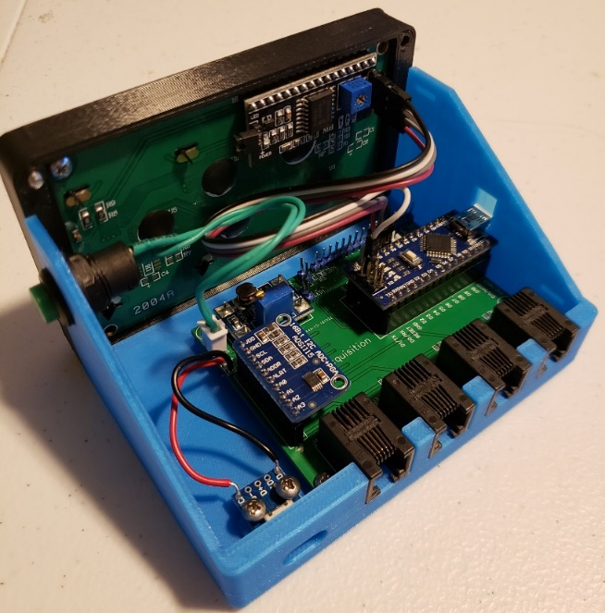

**Figure 3**. Photo of the data acquisition system based on an Arduino Nano using a 4-channel 16-bit analog to digital converter (ADS1115), attached directly to a 4x20 LCD to display live measurements.

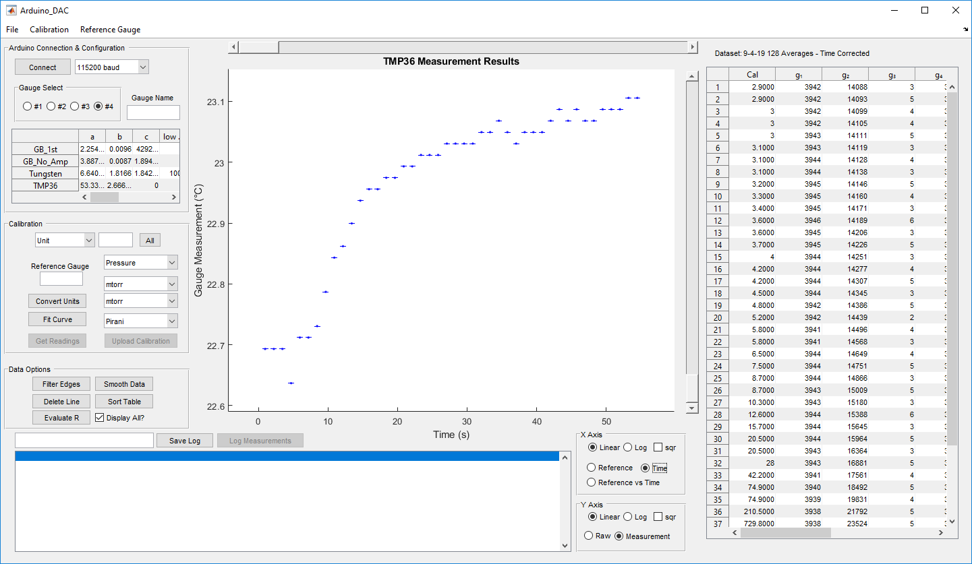

**Figure 4**. GUI interface developed with Matlab's GUIDE package showing an example run. A computer connects to the Arduino and reads the reference gauge, plots the collected data and performs a curve fit.

The controller is powered by a 5 V microUSB input to make it compatible with most cellular phone chargers or single board computer power supplies. This is boosted to 9 V to give some additional overhead to the 5 V regulators on the Arduino, and gauges. Measurements are read using an inter-integrated circuit (I2C) interface from the ADS1115 and calculated using calibration constants stored in the Arduino EEPROM then displayed on the liquid crystal display (LCD) unit.

Each gauge has 10 programmable settings stored in the EEPROM (see **Table 1**): calibration constants (1,2,3) lower (4) and upper (5) cutoff values, display units (6), calibration curve type (7), number of measurements to average (8), and unit conversion (9,10). Cut-off values determine when voltage measurements are within a valid range for a particular sensor. Each gauge has a 5-character string for displaying the units. Calibration curve type is for distinguishing between linear or non-linear (i.e. Eq. 3). Unit conversion is computed after a measurement is calculated. Averaging can be anywhere from 1 – 256 measurements. Each measurement on the ADS1115 takes 9 ms, thus the measurement window can range from 9 ms to 2.3 s. An optimal range was found to be 64 – 128 samples, or roughly 1 to 2 Hz. The Arduino performs the calculations for standard deviations and reports this value alongside the mean measurement result.

**Table 1**. List of values stored in EEPROM. Values are stored sequentially by gauge, then sequentially by variable type.

|  |  |  |
| --- | --- | --- |
| **Description** | **Variable Type** | **Bytes in memory** |
| Calibration constant α | Float | 16 |
| Calibration constant β | Float | 16 |
| Calibration constant γ | Float | 16 |
| Lower voltage cutoff | Int | 8 |
| Upper voltage cutoff | Int | 8 |
| Display Units | Char | 20 |
| Calibration Curve Type | Byte | 4 |
| # of Averages | Byte | 4 |
| Unit conversion multiplier | Float | 16 |
| Unit conversion offset | Float | 16 |

The EEPROM values are set using the Matlab software. Each parameter can be set manually, but functionality exists for setting each value automatically. Calibration constants are determined performing NLLS to curve fit calibration data. This data is acquired directly from the gauge controller. Corresponding reference gauge measurements can be entered manually or automatically if the reference gauge supports data acquisition.

An algorithm was developed that uses base functionality in Matlab to efficiently curve fit calibration data for a Pirani gauge. Due to the offset term in Eq. 3, the calibration curve cannot be linearized unless the offset value is already known, thus the calibration curve must be computed numerically with NLLS. To obtain a guess, the derivative of Eq. 3 is taken with respect to pressure. The result is defined as *δ* and is expressed by

|  |  |
| --- | --- |
|  | (4) |

where *δ* is estimated by computing the finite difference between measurements. This expression is linearized by taking the inverse square root. A linear regression then obtains an initial guess for *α*, and *β*. An initial guess for *γ* is then computed by solving Eq. 3 for *γ* and averaging the results using the initial guess for *α*, and *β*. The NLLS curve fit is then done applying the *fminsearch* function on the squared sum of errors (SSE) using the initial guess values found previously. Initial validation of the algorithm was done by generating prepared data that have exact solutions. This method was robust so long as there was sufficient variance, and the datasets contains the inflection of the s-curve.

Additional tools were added to the software to make it useful as a data analysis program. Data-logging was added and runs continuously until the user issues a stop command. With sampling at 2 Hz, and an overnight run can generate thousands of data points. Data can be saved as a comma separated variable (CSV) file. The software can open CSV data files for running data analysis even when not attached to a gauge. Gauge parameters can be saved and later loaded. Figures can be exported from the software that have been reformatted for display in presentations.

4. Results

The gauge and associated controller were validated against a commercial convection enhanced Pirani style gauge (Convectron, Granville-Philips, Longmont, Colorado) and capacitive diaphragm gauge (CDG, MKS Baratron Type 722A, Andover, Massachusetts). This was to verify that a calibration curve would be consistent, independent of the style of reference gauge. Though still a secondary reference gauge, a CDG provides an alternative source for comparison being a higher quality gauge. It also validated the use of a Convectron, as CDG gauges measurements are not dependent upon ambient temperature or gas species. Our Convetron readout did not support data-logging, so all pressure measurements were entered manually and thus have fewer data points. Since no temperature compensation was utilized in these devices, thermal drift was explored by logging over 24-h periods in a room that fluctuates ~3 °C. The experimental setup used is shown in **Figure 5**.

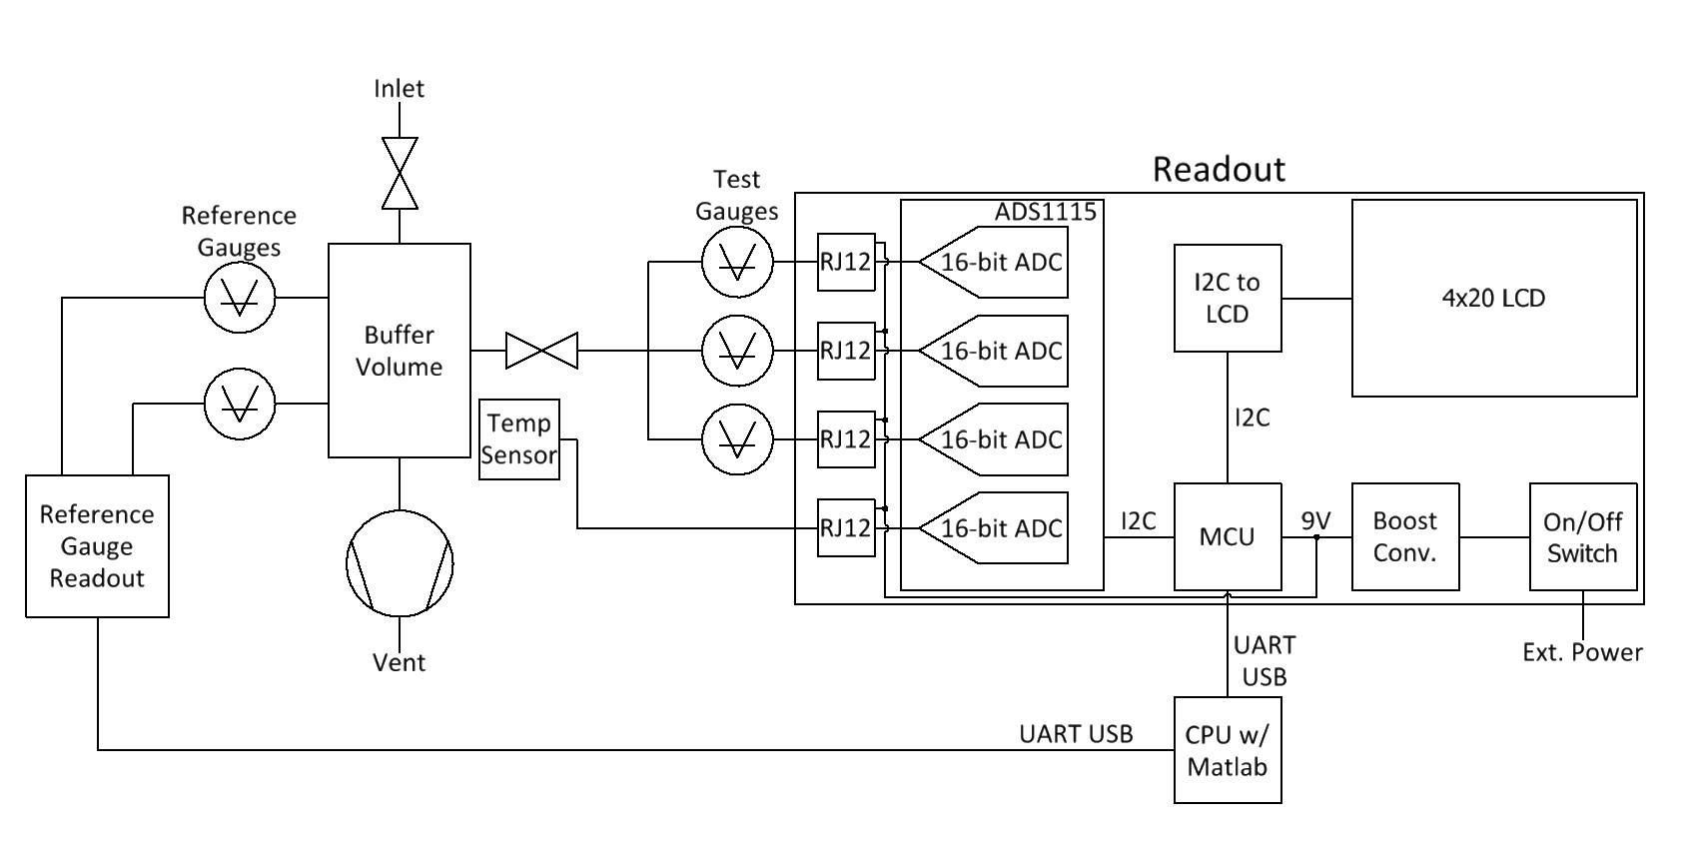

**Figure 5.** Schematic diagram of the vacuum system with test gauges and how they interface to the readout and host computer.

4.1 Proof of Concept by Comparison against Convectron

A Convectron® was used as a baseline calibration for initially building and configuring each gauge. Once the sensing element is attached it first has the temperature tuned using R3 (See **Figure 1**). The voltage across the filament is measured at both atmosphere and vacuum to ensure stability and a satisfactory dynamic range. Tungsten filament (eTopLighting P/N: T5-12V-4W) voltage would typically be between 0.1 – 0.3 V and the glass bead thermistors (Littelfuse Inc. P/N: GP101B0M) voltage would be between 1.35 – 1.5 V from vacuum to atmosphere. It was found that the increased range by adjusting the offset null was unnecessary and introduced a non-linear error term that could not be calibrated out. Thus, only gain is tuned to achieve just under 5 V at atmospheric pressures. Due to the low initial voltage of the tungsten, the dynamic range gained the most improvement with amplification.

Both the glass bead and tungsten sensors gave the expected “S-curve” which is predicted by Equation 3. Tungsten generally showed a much closer fit with <5% correlation error after calibration, whereas the glass bead only reliably measured less than 10% correlation error. It is interpreted that this is due to the lower sensitivity and higher offset bias of the glass bead sensor. Some fits showed non-randomized residuals, suggesting the calibration can be impacted by ambient temperature conditions. However, this systematic bias error would not impact typical usage of a Pirani gauge. A typical calibration curve is shown in **Figure 6**.

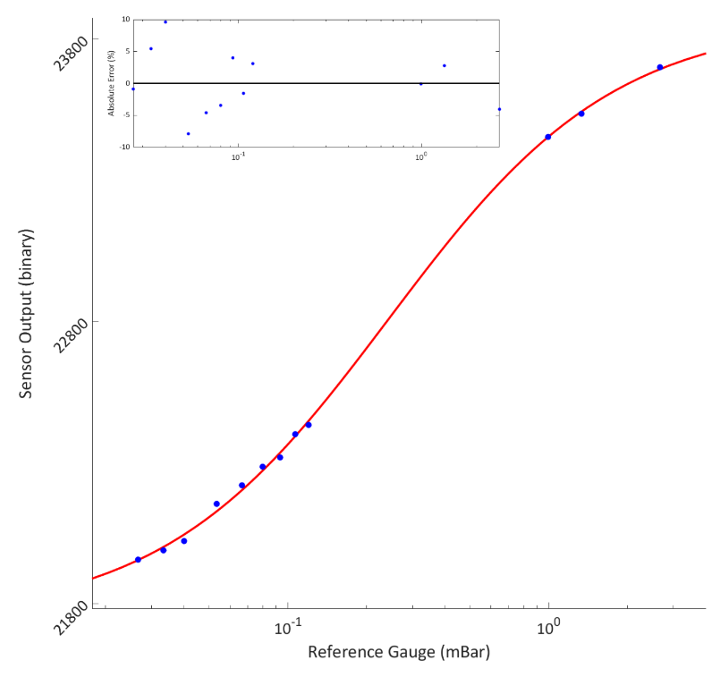

**Figure 6**. Typical results for calibrating of a glass bead Pirani gauge against a Convectron reference gauge by manually recording pressure.

4.2 Validation of Results, and Autocalibrating with a CDG

A CDG was used to explore automatically creating a calibration curve. Using a CDG produces highly accurate pressure measurements that are independent of gas species, and ambient temperature. The CDG used here is an MKS Baratron® Type 722A, with a Terranova® Model 908A readout. Generating a calibration curve was done by disconnecting the vacuum pump, and datalogging (more discussion on datalogging in 4.3) the pressure of the system as a slow leak gradually brought the system towards atmosphere (~60 nmol s-1). Leaks were sufficiently slow that mass transport effects ignored in Equation 3 would remain insignificant. This was verified after generating the calibration curve. Data points were probed post calibration using the method described for the Convectron calibration to ensure the gauge would produce a consistent measurement. Post calibration measurements were consistent and did not show drift beyond the correlation errors present in the calibration curve.

Two sampling issues in the auto-calibration method were addressed in the post-processing of data. Since the leak increased pressure approximately linearly, the large number of data points creates a bias towards higher pressures when applying a curve fit. Additionally, the sensitivity of the ADC is higher than the sensitivity of the reference gauge. Especially at lower pressure measurements, the binary output may have a large range of values that correspond to a single pressure. Both of these issues are handled by implementing a boxcar average with bins logarithmically spaced.

The calibration curve did not show any major changes in shape when comparing against a CDG. Correlation errors were very small if only evaluating the regime of 10-2 mbar to 1 mbar. However, temperature dependence introduces more error at higher pressures, and depending on the stability of the ambient temperature, can present a systematic error that becomes apparent in the residuals. One method used to reduce this effect was implement multiple curves at different times/temperatures prior to doing the boxcar averaging, providing sensor outputs that correlate with an average temperature. Using this approach, correlation error in the gauge measurement typically remains below 5% (see **Figure 7**).

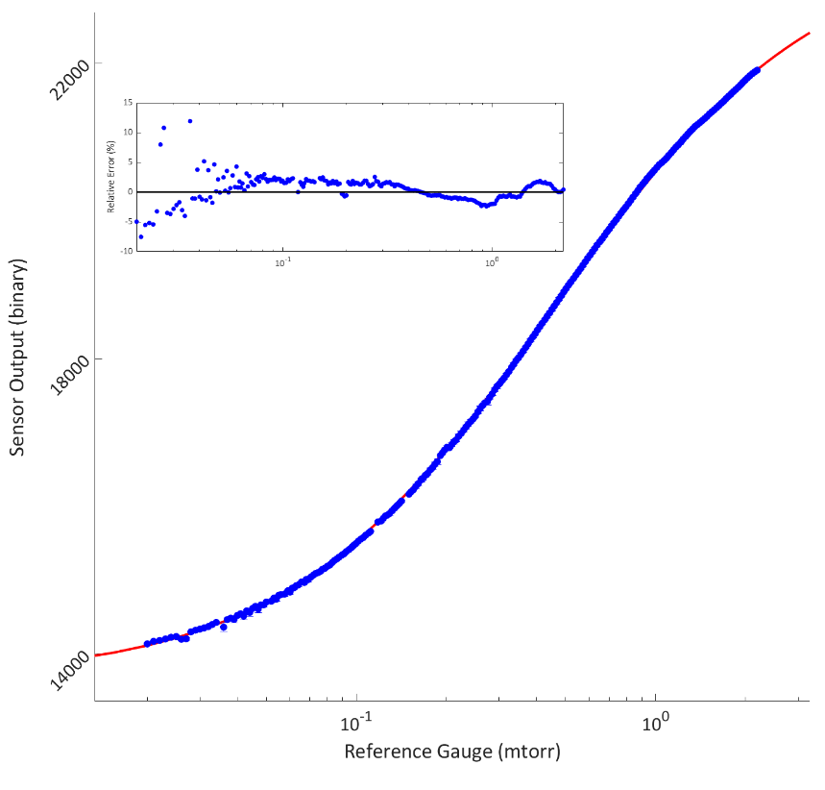

**Figure 7**. Tungsten filament calibration curve produced using the auto-calibration method. This curve contains three runs at different times that were boxcar averaged.

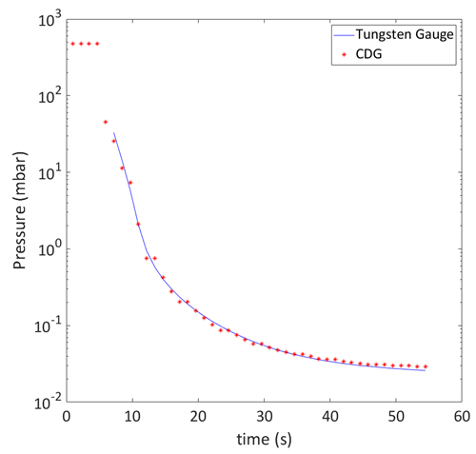4.3 Datalogging

Data-logging is another useful feature of the software which was developed, extensively tested for reliability, and used to identify the errors of calibration not easily quantified during the calibration sequences described prior. Averaging parameters were set low (1 to 4) on the gauges to get up to 10 samples per second. This was found to be excessive by putting a large demand on the computer system, and produced very noisy data that needed additional processing to calculate statistical significance. Averaging 64 measurements gave optimal results as it was low demand on the computer system and reported standard deviations from the Arduino were relevant to finding either instabilities in the gauge, or highlighting large pressure change occurring during the averaging window.

**Figure 8**. Example data log of the tungsten gauge compared to the CDG during a pump-down cycle on the vacuum system with measurements given from 64 samples.

Capabilities to log measurements automatically allowed for improved capture of a pump down cycle compared to the CDG used in this study. At pressures within the valid measurement range, the tungsten gauge was able to track a pump-down sequences with higher precision (See **Figure 8**). The CDG would often register the same pressure measurement for multiple data captures, whereas the tungsten gauge would show a continuous drop in pressure.

An important consideration is that the gauge is less sensitive to temperature fluctuations under vacuum (<1 mbar), as the influence from the viscous flow thermal transport is insignificant. To test this, the system was pumped down to vacuum (<1mbar), and allowed to reach higher pressures with a leak rate of approximately 0.19 mbar h-1. Data-logging over a 24-h period (0 – 4.5 mbar, **Figure 9**) captured the effect of temperature as pressure measurements started to fluctuate with ambient temperature. Measurement fluctuations are virtually undetectable below 1 mbar, sensitivity becomes greatly affected after 3 mbar, and at 4 mbar temperature sensitivity completely dominates. The increase by approximately 1 °C results in a false measurement that is ~1 mbar below the true pressure of 4 mbar. Thus, for a gauge that only measures below 1 mbar, temperature compensation is of minimal importance. In the calibration cycle, this point can be identified and set as the upper cutoff on the readout.

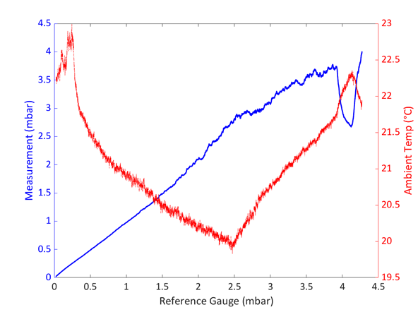

**Figure 9**. Tungsten gauge pressure measurement correlated with ambient temperature, compared against the low pressure measured by the reference gauge. Pressure was parameterized by time due to a slow leak into the system.

5. Discussion

Typical resulting calibration constants to equation 3 are given in **Table 2**. There is a small deviation between comparisons made with the Convectron and CDG, which is expected to be due to difference in calibration between the CDG and Convectron used for comparison. Both tungsten and glass bead gauges gave similar levels of accuracy when calibrated against the respective gauge. What this demonstrated is the calibration technique can be applied successfully across gauges and gauge filament types.

**Table 2.** Results of calibration constants for different heating elements compared against the given reference gauge.

|  |  |  |  |  |
| --- | --- | --- | --- | --- |
| **Calibration Constant** | **Tungsten vs Convectron** | **Tungsten vs CDG** | **Glass Bead vs Convectron** | **Glass Bead vs CDG** |
| α (mbar-1) | 5.25x108 | 6.65x108 | 3.82x108 | 9.74x108 |
| β (mbar-1) | 1.17 | 1.70 | 3.93 | 5.05 |
| γ (binary2) | 1.86x108 | 1.87x108 | 4.74x108 | 4.30x108 |

When considering the limits of P in Equation 3, the upper limit becomes the ratio of *α* and *β*, plus the offset term *γ*. An ideal gauge would have a *β*=*γ*=0 as this would result in a pressure measurement that is linear with constant sensitivity. *β* determines the upper limit of the gauge, as pressure becomes a large value, the 1 in the denominator becomes insignificant. The pressure terms in the numerator and denominator cancel leaving only temperature dependence. Tungsten performed better compared to the glass bead thermistor in respect to sensitivity and range, having both a larger *α* and a smaller *β* (see **Table 2**). In this regard, tungsten also showed significantly better performance with respect to offset; consistently having a lower offset value *γ*. This is due to the low emissivity of tungsten wire when compared to a glass bead.

A few trade-offs exist that make glass bead thermistor more appealing in certain cases. The primary advantage being ease of construction, and cleaning a sensor that has been contaminated. Glass bead thermistor can be easily be wiped with alcohol and not deform. Glass bead thermistors also have very consistent characteristics when purchased from vendors. Tungsten filaments would likely need to be made in-house to ensure consistent behavior (e.g. cold resistance, and filament size). The disadvantage of reduced sensitivity with a glass bead thermistor compared to a metal filament is generally not a large concern for most vacuum applications.

6. Conclusion

Here we have presented a modern implementation of a Pirani gauge, a century old device. Our results have not shown any changes to the physics of how these devices behave, but we have shown off-the shelf components have provided a means to produce a low-cost Pirani gauge that measures accurately below 2 mbar. The use of a circuit board as a vacuum capable gauge material has been proven successful for rough vacuum applications. Though tungsten wire extracted from a light bulb yielded superior results, it proves to be more difficult to create a Pirani gauge with this type of sensor when compared to the Glass Bead thermistor.

The readout developed here provided a calibration method and robust curve fitting method for a large variety of Pirani gauges. Here a temperature sensor is used alongside a Pirani gauge to demonstrate the ability of the readout to operate multiple types of sensors. The software was made as general as possible to support additional types of gauges. All source code is available to support development of new sensors, or connecting old analog sensors (see supplemental materials).

**Supplementary Materials:** The following are available online at www.mdpi.com/xxx/s1

**Author Contributions:** conceptualization, Erik Sánchez. and Alex Smith; methodology, Alex Smith.; software, Alex Smith; validation, Andrew Rice, Alex Smith, and Erik Sánchez.; formal analysis, Alex Smith, and Andrew Rice.; investigation, Alex Smith; resources, Andrew Rice, and Erik Sánchez; data curation, Alex Smith; writing—original draft preparation, Alex Smith; writing—review and editing, Andrew Rice, and Erik Sánchez.; visualization, Alex Smith; supervision, Erik Sánchez.; project administration, Erik Sánchez.; funding acquisition, Erik Sánchez

**Funding:** The authors would like to thank Portland State University (PSU) Research Sponsored project's financial assistance through the University Venture Development Fund (UVDF) and PSU Faculty Enhancement Fund. This submission was also funded by the Portland State University Open Access Article Processing Charge Fund, administered by the Portland State University Library.

**Acknowledgments:** The authors would like to express gratitude to Autodesk for making their software free for students to use in their education. Roy Schmaus posted an excellent tutorial on building glass bead thermistor pirani gauges that helped with inspiration and some circuit design aspects [25]. Lastly, all the members of the Stable Isotope Lab at Portland State University for their assistance in reviewing this manuscript.

**Conflicts of Interest:** The authors declare no conflict of interest.

References

1. Jousten, K. Vacuum metrology and its impact on research and industry: From state of the art measurements to future trends. Vakuum in Forschung und Praxis **2019**, 31, 16–22. DOI: 10.1002/vipr.201900715.
2. Pirani, M; Continuously Indicating Vacuum Gauge. Deutsche Physcs. Ges. Verk **1906**, 686, Vol. 8
3. van Herwaarden, A.W.; Sarro, P.M. Performance of integrated thermopile vacuum sensors. Journal of Physics E: Scientific Instruments 1988, 21, 1162–1167.Gu, L; Bart, S. F; Wenzel, O.; Micro-Pirani Vacuum Gauges. US 2015/0276536 A1 US, Oct 1, **2015**
4. Gu, L; Bart, S. F; Wenzel, O.; Micro-Pirani Vacuum Gauges. US 2015/0276536 A1 US, Oct 1, **2015**
5. Zhang, G.; Lai, J.; Kong, Y.; Jiao, B.; Yun, S.; Ye, Y. Study of cavity effect in micro-Pirani gauge chamber with improved sensitivity for high vacuum regime. AIP Advances **2018**, 8, 055131. DOI: 10.1063/1.5025611.
6. Sturesson, P.; Klintberg, L.; Thornell, G. Pirani microgauge fabricated of high-temperature co-fired ceramics with integrated platinum wires. Sensors and Actuators A: Physical **2019**, 285, 8–16. DOI: 10.1016/j.sna.2018.10.008.
7. Piotto, M.; Del Cesta, S.; Bruschi, P. A CMOS compatible micro-Pirani vacuum sensor based on mutual heat transfer with 5-decade operating range and 0.3 Pa detection limit. Sensors and Actuators A: Physical **2017**, 263, 718–726. DOI: 10.1016/j.sna.2017.06.033.
8. Fekete, A.-Z.; Jakab-Farkas, L. Development of a Pressure Measuring Unit Based on a Thermal Conductivity Gauge and a Low-Cost Embedded Solution for Mid-Range Vacuum Applications. Műszaki Tudományos Közlemények **2018**, 9, 79–82. DOI: 10.33894/mtk-2018.09.15
9. Cho, Y.S. Development of Digital Vacuum Pressure Sensor Using MEMS Analog Pirani Gauge. Journal of Information and Communication Convergence Engineering **2017**, 15, 232–236.

DOI: 10.6109/jicce.2017.15.4.232.

1. ADS111x Ultra-Small, Low-Power, I 2C-Compatible, 860-SPS, 16-Bit ADCs With Internal Reference, Oscillator, and Programmable Comparator Available online:

http://www.ti.com/lit/ds/symlink/ads1114.pdf (accessed on Sep 13, 2019).

1. Low Voltage Temperature Sensors Available online: https://www.analog.com/media/en/technical-documentation/data-sheets/TMP35_36_37.pdf (accessed on Sep 13, 2019).
2. Jousten, K. Gauges for fine and high vacuum. **2007**, 22 p. DOI: 10.5170/CERN-2007-003.65.
3. Von Ubisch, H. Hot-Wire Manometers for Chemical Applications. Anal. Chem. **1952**, 24, 931–938.

DOI: 10.1021/ac60066a003

1. Dushman, S.; *Scientific foundations of vacuum technique*; Ed.; 2. ed.; Wiley: New York, 1962; ISBN 978-0-471-22803-5.
2. Leck, J.H. The high temperature Pirani gauge. Journal of Scientific Instruments **1952**, 29, 258–263.
3. Glockler, G.; Ven Horst, H. The Pirani Gauge. Science **1952**, 116, 364–367. DOI: 10.1126/science.116.3014.364.
4. Jousten, K. *Handbook of vacuum technology;* Ed.; Second, completely revised and updated edition.; Wiley-VCH Verlag GmbH & Co. KGaA: Weinheim, 2016; ISBN 978-3-527-40723-1.
5. Leck, J.H. A feedback controlled Pirani gauge. Journal of Scientific Instruments **1958**, 35, 107–108.
6. Bradley, R.S. A thermistor McLeod gauge for a pressure range 1-10-7mm of mercury. Journal of Scientific Instruments **1954**, 31, 129–130.
7. Chatterjee, S.; Halder, A.K.; Sengupta, K.; Maiti, H.S. A vacuum gauge using positive temperature coefficient thermistor as the sensor. Rev. Sci. Instrum. **2000**, 71, 4670. DOI: 10.1063/1.1287619.
8. TLV07 36-V Precision, Rail-to-Rail Output Operational Amplifier Available online: http://www.ti.com/lit/ds/symlink/tlv07.pdf (accessed on Sep 13, 2019).
9. INA826 Precision, 200-µA Supply Current, 3-V to 36-V Supply Instrumentation Amplifier with Rail-to-Rail Output Available online: http://www.ti.com/lit/ds/symlink/ina826.pdf (accessed on Sep 15, 2019).
10. Stark, B.H.; Najafi, K. An integrated process for post-packaging release and vacuum sealing of electroplated nickel packages. In Proceedings of the TRANSDUCERS ’03. 12th International Conference on Solid-State Sensors, Actuators and Microsystems. Digest of Technical Papers (Cat. No.03TH8664); IEEE: Boston, MA, USA, **2003**; Vol. 2, pp. 1911–1914. DOI: 10.1109/SENSOR.2003.1217165
11. Junseok Chae; Giachino, J.M.; Najafi, K. Fabrication and Characterization of a Wafer-Level MEMS Vacuum Package With Vertical Feedthroughs. J. Microelectromech. Syst. **2008**, 17, 193–200.

DOI: 10.1109/JMEMS.2007.910258

1. Schmaus, R. Thermistor Vacuum Gauge Available online:

http://www3.telus.net/schmaus2/vacf/thermis.html (accessed on Apr 10, 2020).

|  |  |
| --- | --- |
| copyRight | © 2019 by the authors. Submitted for possible open access publication under the terms and conditions of the Creative Commons Attribution (CC BY) license (http://creativecommons.org/licenses/by/4.0/). |

1. Measurements by the ADS1115 from sensors are never converted to voltage. All sensor values are reported as their binary value, which is ~0.1875 mV/bit.